
Company Quarterly OKR Template
How to use this template: Please start by extending the OKR Dashboard Template in Excel — add the quarterly framing, KPI tiles, and risk register there. Once that’s complete, reuse screenshots and tables in Word, PowerPoint, and Google Slides so all formats follow the same structure without extra builds.
Your Logo
Company Name
Address Line 1
Address Line 2
Updated on MM/DD/YY

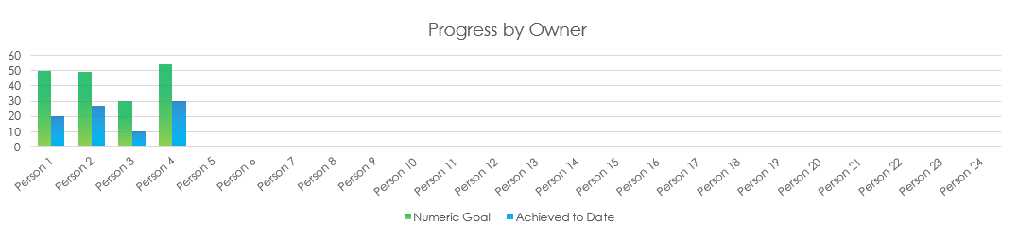

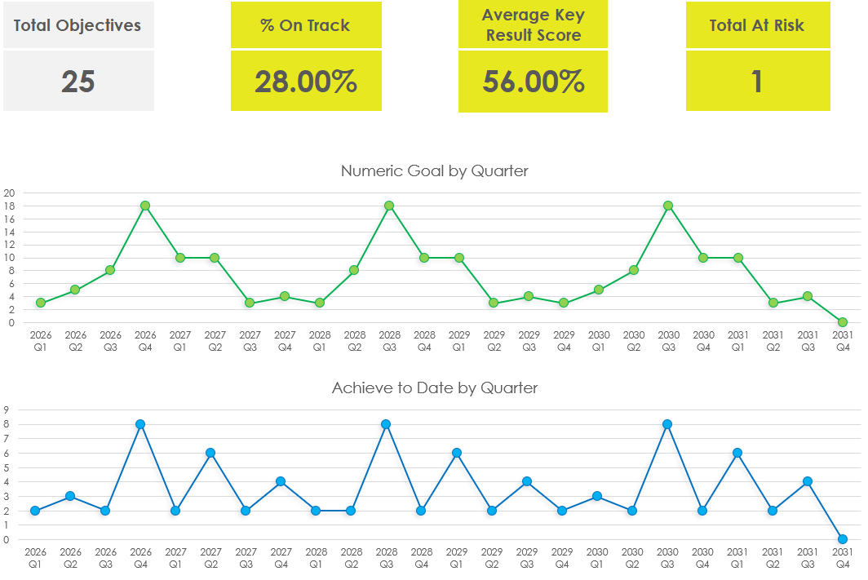

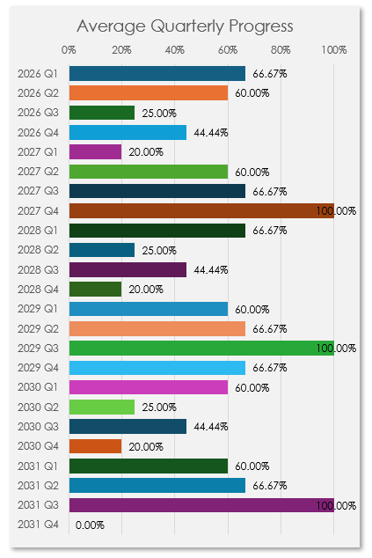
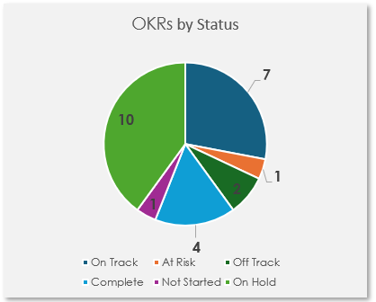

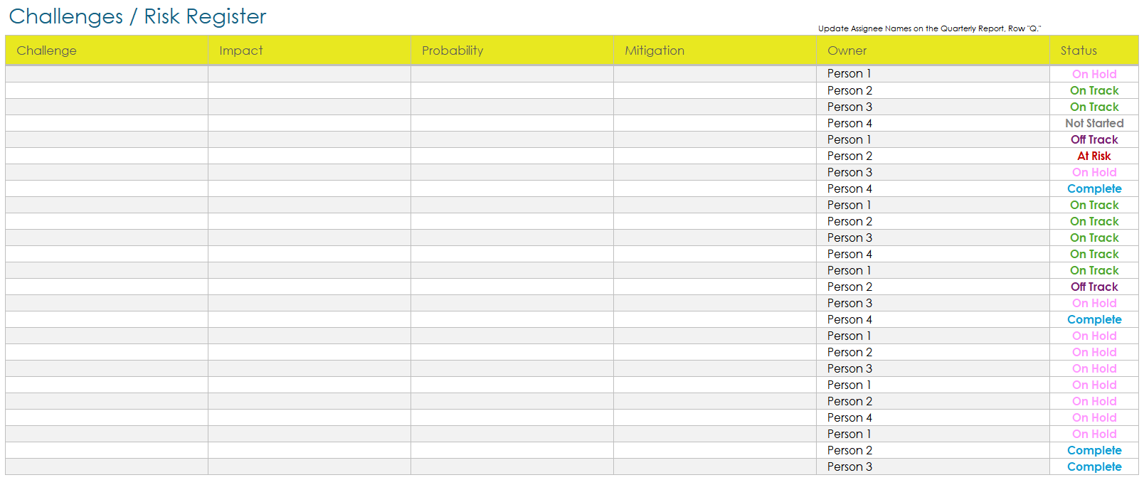
DISCLAIMER

Any articles, templates, or information provided by Smartsheet on the website are for reference only. While we strive to keep the information up to date and correct, we make no representations or warranties of any kind, express or implied, about the completeness, accuracy, reliability, suitability, or availability with respect to the website or the information, articles, templates, or related graphics contained on the website. Any reliance you place on such information is therefore strictly at your own risk.

