**](https://www.smartsheet.com/try-it?trp=12361&utm_source=template-word&utm_medium=content&utm_campaign=Sample+Customer+Survey-word-12361&lpa=Sample+Customer+Survey+word+12361)**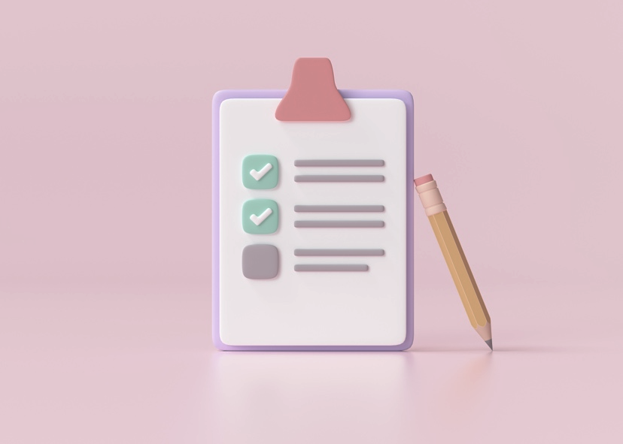

**Customer Survey (SWOT Analysis)**

1. How easy was it to purchase our product/service?

|  |
| --- |
|  |

1. How quickly did you receive our product/service?

|  |
| --- |
|  |

1. Did the product/service work well?

|  |
| --- |
|  |

1. If there was an issue, was our customer service helpful?

|  |
| --- |
|  |

1. Would you recommend our product/service? Why or why not?

|  |
| --- |
|  |

|  |
| --- |
| **DISCLAIMER**  Any articles, templates, or information provided by Smartsheet on the website are for reference only. While we strive to keep the information up to date and correct, we make no representations or warranties of any kind, express or implied, about the completeness, accuracy, reliability, suitability, or availability with respect to the website or the information, articles, templates, or related graphics contained on the website. Any reliance you place on such information is therefore strictly at your own risk. |