
Service
Work Order
Template Example

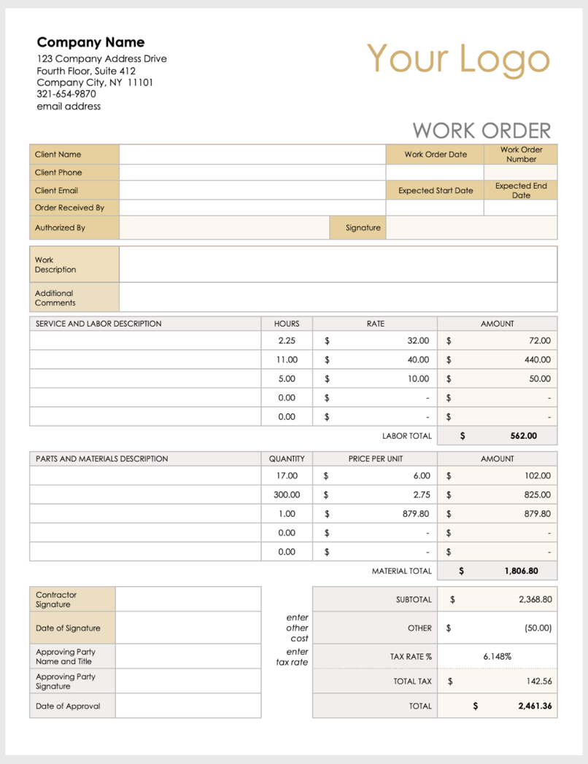

Company Name
123 Company Address Drive
Fourth Floor, Suite 412
Company City, NY 11101
321-654-9870
email address
Your Logo
 |  | WORK ORDER
Client Name |  |  | Work Order Date | Work Order Number
Client Phone
Client Email |  |  | Expected Start Date | Expected End Date
Order Received By
Authorized By |  | Signature
Work
Description
Additional Comments

SERVICE AND LABOR DESCRIPTION |  | HOURS | RATE | AMOUNT
 |  | 2.25 | $ 32.00 | $ 72.00
 |  | 11.00 | $ 40.00 | $ 440.00
 |  | 5.00 | $ 10.00 | $ 50.00
 |  | 0.00 | $ - | $ -
 |  | 0.00 | $ - | $ -
 |  |  | LABOR TOTAL | $ 562.00
PARTS AND MATERIALS DESCRIPTION |  | QUANTITY | PRICE PER UNIT | AMOUNT
 |  | 17.00 | $ 6.00 | $ 102.00
 |  | 300.00 | $ 2.75 | $ 825.00
 |  | 1.00 | $ 879.80 | $ 879.80
 |  | 0.00 | $ - | $ -
 |  | 0.00 | $ - | $ -
 |  |  | MATERIAL TOTAL | $ 1,806.80
Contractor Signature |  |  | SUBTOTAL | $ 2,368.80
Date of Signature |  | enter  other cost | OTHER | $ (50.00)
Approving Party  Name and Title |  | enter  tax rate | TAX RATE % | 6.148%
Approving Party Signature |  |  | TOTAL TAX | $ 142.56
Date of Approval |  |  | TOTAL | $ 2,461.36

Company Name
123 Company Address Drive
Fourth Floor, Suite 412
Company City, NY 11101
321-654-9870
email address
Your Logo
 |  | WORK ORDER
Client Name |  |  | Work Order Date | Work Order Number
Client Phone
Client Email |  |  | Expected Start Date | Expected End Date
Order Received By
Authorized By |  | Signature
Work
Description
Additional Comments

SERVICE AND LABOR DESCRIPTION |  | HOURS | RATE | AMOUNT
 |  |  |  | $ -
 |  |  |  | $ -
 |  |  |  | $ -
 |  |  |  | $ -
 |  |  |  | $ -
 |  |  | LABOR TOTAL
PARTS AND MATERIALS DESCRIPTION |  | QUANTITY | PRICE PER UNIT | AMOUNT
 |  |  | $ - | $ -
 |  |  | $ - | $ -
 |  |  | $ - | $ -
 |  |  | $ - | $ -
 |  |  | $ - | $ -
 |  |  | MATERIAL TOTAL
Contractor Signature |  |  | SUBTOTAL
Date of Signature |  | enter  other cost | OTHER
Approving Party  Name and Title |  | enter  tax rate | TAX RATE % | %
Approving Party Signature |  |  | TOTAL TAX
Date of Approval |  |  | TOTAL | $

DISCLAIMER

Any articles, templates, or information provided by Smartsheet on the website are for reference only. While we strive to keep the information up to date and correct, we make no representations or warranties of any kind, express or implied, about the completeness, accuracy, reliability, suitability, or availability with respect to the website or the information, articles, templates, or related graphics contained on the website. Any reliance you place on such information is therefore strictly at your own risk.

