
Printable Work Order
Request Template

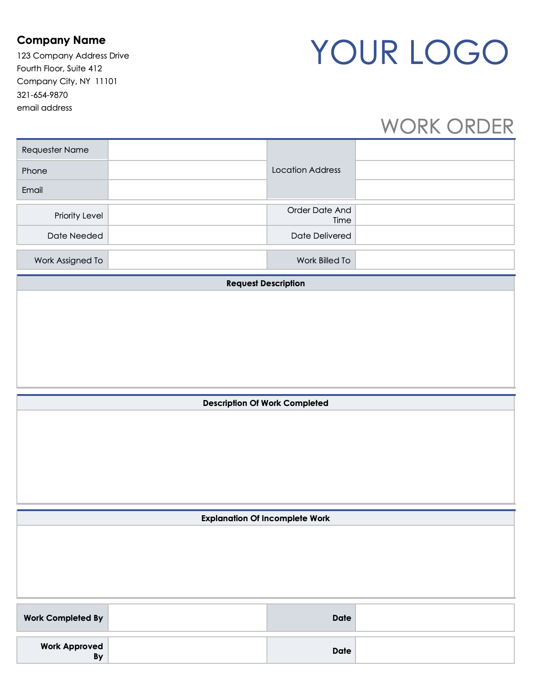

Company Name |  | YOUR LOGO
123 Company Address Drive
Fourth Floor, Suite 412
Company City, NY 11101
321-654-9870
email address
 |  |  | WORK ORDER
Requester Name |  | Location Address
Phone
Email
Priority Level |  | Order Date And Time
Date Needed |  | Date Delivered
Work Assigned To |  | Work Billed To
Request Description
Description Of Work Completed
Explanation Of Incomplete Work
Work Completed By |  | Date
Work Approved  By |  | Date

DISCLAIMER

Any articles, templates, or information provided by Smartsheet on the website are for reference only. While we strive to keep the information up to date and correct, we make no representations or warranties of any kind, express or implied, about the completeness, accuracy, reliability, suitability, or availability with respect to the website or the information, articles, templates, or related graphics contained on the website. Any reliance you place on such information is therefore strictly at your own risk.

