**](https://www.smartsheet.com/try-it?trp=8963&utm_source=template-word&utm_medium=content&utm_campaign=Maintenance+Work+Order-word-8963&lpa=Maintenance+Work+Order+word+8963)Microsoft Word   
Maintenance**

**Work Order   
Template**

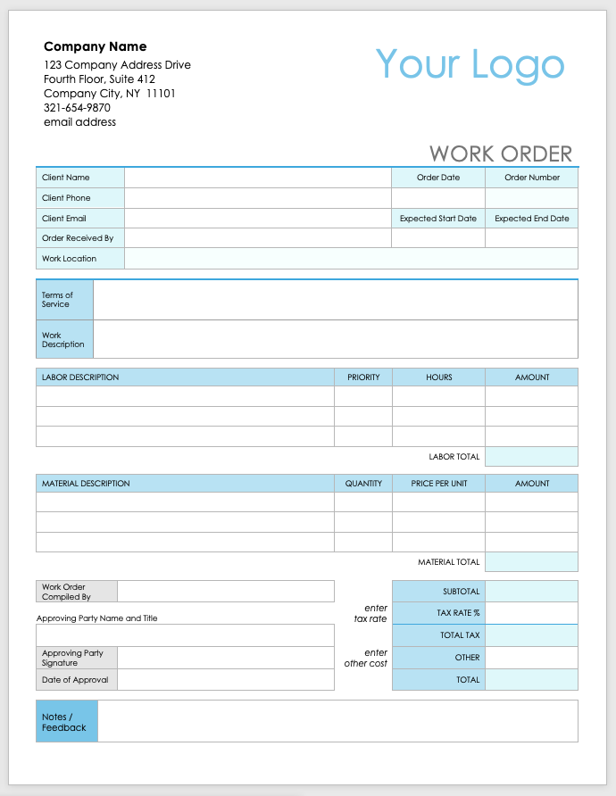

**Company Name**

123 Company Address Drive

Fourth Floor, Suite 412

Company City, NY 11101

321-654-9870

email address

Your Logo

|  |  |  |  |
| --- | --- | --- | --- |
| WORK ORDER | | | |
| Client Name |  | Order Date | Order Number |
| Client Phone |  |  |  |
| Client Email |  | Expected Start Date | Expected End Date |
| Order Received By |  |  |  |
| Work Location |  | | |

|  |  |
| --- | --- |
| Terms of Service |  |
| Work Description |  |

|  |  |  |  |  |
| --- | --- | --- | --- | --- |
| LABOR DESCRIPTION | | PRIORITY | HOURS | AMOUNT |
|  | |  |  |  |
|  | |  |  |  |
|  | |  |  |  |
|  | | | LABOR TOTAL | **0** |
|  |  |  |  |  |
| MATERIAL DESCRIPTION | | QUANTITY | PRICE PER UNIT | AMOUNT |
|  | |  |  |  |
|  | |  |  |  |
|  | |  |  |  |
|  | | | MATERIAL TOTAL | **0** |

|  |  |  |  |  |
| --- | --- | --- | --- | --- |
| Work Order Compiled By |  |  | SUBTOTAL |  |
| Approving Party Name and Title | | *enter  tax rate* | TAX RATE % |  |
|  | |  | TOTAL TAX |  |
| Approving Party Signature |  | *enter  other cost* | OTHER |  |
| Date of Approval |  |  | TOTAL |  |

|  |  |
| --- | --- |
| Notes /  Feedback |  |

|  |
| --- |
| **DISCLAIMER**  Any articles, templates, or information provided by Smartsheet on the website are for reference only. While we strive to keep the information up to date and correct, we make no representations or warranties of any kind, express or implied, about the completeness, accuracy, reliability, suitability, or availability with respect to the website or the information, articles, templates, or related graphics contained on the website. Any reliance you place on such information is therefore strictly at your own risk. |