**Microsoft Word   
Land Surveying   
Work Order   
](https://www.smartsheet.com/try-it?trp=8963&utm_source=template-word&utm_medium=content&utm_campaign=Land+Surveying+Work+Order-word-8963&lpa=Land+Surveying+Work+Order+word+8963)**

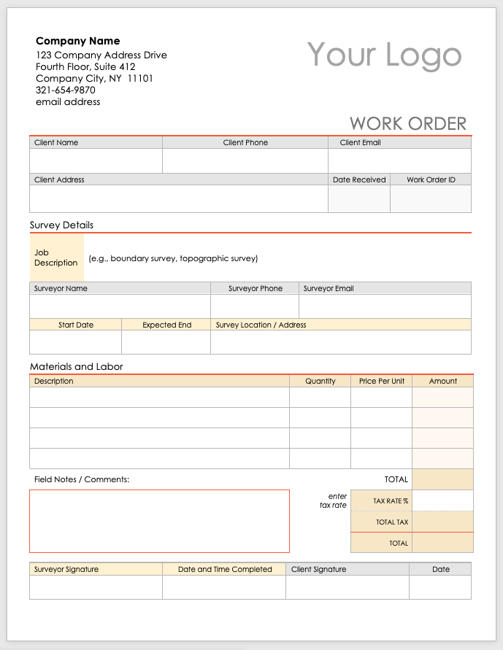

**Company Name**

123 Company Address Drive

Fourth Floor, Suite 412

Company City, NY 11101

321-654-9870

email address

Your Logo

|  |  |  |  |
| --- | --- | --- | --- |
| WORK ORDER | | | |
| Client Name | Client Phone | Client Email | |
|  |  |  | |
| Client Address | | Date Received | Work Order ID |
|  | |  |  |

Survey Details

|  |  |  |  |  |
| --- | --- | --- | --- | --- |
| Job Description | (e.g., boundary survey, topographic survey) | | | |
| Surveyor Name | | | Surveyor Phone | Surveyor Email |
|  | | |  |  |
| Start Date | | Expected End | Survey Location / Address | |
|  | |  |  | |

Materials and Labor

|  |  |  |  |  |  |  |
| --- | --- | --- | --- | --- | --- | --- |
| Description | | | Quantity | | Price Per Unit | Amount |
|  | | |  | |  |  |
|  | | |  | |  |  |
|  | | |  | |  |  |
|  | | |  | |  |  |
| Field Notes / Comments: |  |  |  | | TOTAL |  |
|  | | | |  | TAX RATE % |  |
|  | TOTAL TAX |  |
|  | TOTAL |  |

|  |  |  |  |
| --- | --- | --- | --- |
| Surveyor Signature | Date and Time Completed | Client Signature | Date |
|  |  |  |  |

|  |
| --- |
| **DISCLAIMER**  Any articles, templates, or information provided by Smartsheet on the website are for reference only. While we strive to keep the information up to date and correct, we make no representations or warranties of any kind, express or implied, about the completeness, accuracy, reliability, suitability, or availability with respect to the website or the information, articles, templates, or related graphics contained on the website. Any reliance you place on such information is therefore strictly at your own risk. |