**](https://www.smartsheet.com/try-it?trp=8963&utm_source=template-word&utm_medium=content&utm_campaign=Construction+Work+Order-word-8963&lpa=Construction+Work+Order+word+8963)Construction**

**Work Order**  **Template**

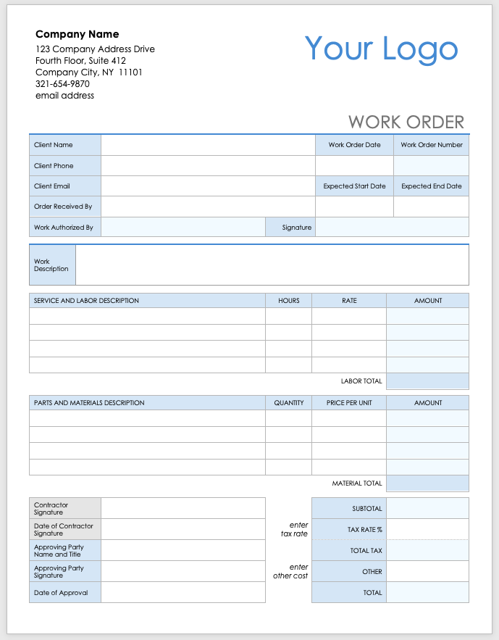



|  |  |  |  |  |
| --- | --- | --- | --- | --- |
| WORK ORDER | | | | |
| Client Name |  | | Work Order Date | Work Order Number |
| Client Phone |  | |  |  |
| Client Email |  | | Expected Start Date | Expected End Date |
| Order Received By |  | |  |  |
| Work Authorized By |  | Signature |  | |

|  |  |
| --- | --- |
| Work Description |  |

|  |  |  |  |  |  |
| --- | --- | --- | --- | --- | --- |
| SERVICE AND LABOR DESCRIPTION | | | HOURS | RATE | AMOUNT |
|  | | |  |  |  |
|  | | |  |  |  |
|  | | |  |  |  |
|  | | |  |  |  |
|  | | | | LABOR TOTAL |  |
|  |  | |  |  |  |
| PARTS AND MATERIALS DESCRIPTION | | | QUANTITY | PRICE PER UNIT | AMOUNT |
|  | | |  |  |  |
|  | | |  |  |  |
|  | | |  |  |  |
|  | | |  |  |  |
|  | | | | MATERIAL TOTAL |  |
|  |  | |  |  |  |
| Contractor Signature | |  |  | SUBTOTAL |  |
| Date of Contractor Signature | |  | *enter  tax rate* | TAX RATE % |  |
| Approving Party  Name and Title | |  |  | TOTAL TAX |  |
| Approving Party Signature | |  | *enter  other cost* | OTHER |  |
| Date of Approval | |  |  | TOTAL |  |

|  |
| --- |
| **DISCLAIMER**  Any articles, templates, or information provided by Smartsheet on the website are for reference only. While we strive to keep the information up to date and correct, we make no representations or warranties of any kind, express or implied, about the completeness, accuracy, reliability, suitability, or availability with respect to the website or the information, articles, templates, or related graphics contained on the website. Any reliance you place on such information is therefore strictly at your own risk. |