
Microsoft Word
Basic Work Order
Template Example

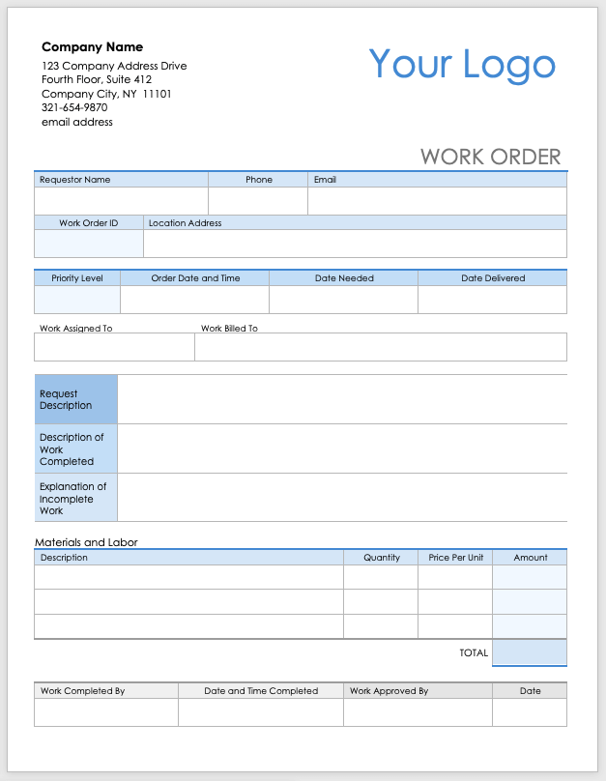
Company Name
123 Company Address Drive
Fourth Floor, Suite 412
Company City, NY 11101
321-654-9870
email address
Your Logo
WORK ORDER
Requestor Name |  | Phone | Email
Romy Bailey |  | 555-678-1234 | Romy@email.com
Work Order ID | Location Address
 | 789 Maple Street, Seattle, WA 98101

Priority Level | Order Date and Time |  | Date Needed | Date Delivered
High | 11/09/20XX 10:00 AM |  | 11/09/20XX | 11/09/20XX
Work Assigned To |  | Work Billed To
Jason Desjardins |  | Romy Bailey

Request Description | Romy requested that the air conditioning system at her property be inspected and repaired  due to insufficient cooling. She also mentioned an issue with the system making strange noises.
Description of Work Completed | • The technician inspected the HVAC system, identified a blocked air filter, and replaced it.  • Checked refrigerant levels, which were low, and recharged the system.  • Cleaned the condenser coils and tested the unit for proper operation.  • The air conditioning unit is now working at full capacity, and no unusual noises were noted  after servicing.
Explanation of Incomplete Work | No incomplete work reported.

Materials and Labor
Description |  |  |  | Quantity | Price Per Unit | Amount
Air Filter Replacement |  |  |  | 1 | $15.00 | $15.00
Refrigerant (R-22) |  |  |  | 1 | $50.00 | $50.00
Labor (2 hours) |  |  |  | 2 | $75.00 | $150.00
Condenser Coil Cleaner |  |  |  | 1 | $20.00 | 20.00
 |  |  |  |  | TOTAL | $235.00

Work Completed By | Date and Time Completed | Work Approved By | Date
Jason Desjardins | 11/09/20XX 2:00 PM | Romy Bailey | 11/09/20XX

Company Name
123 Company Address Drive
Fourth Floor, Suite 412
Company City, NY 11101
321-654-9870
email address
Your Logo
WORK ORDER
Requestor Name |  | Phone | Email
Work Order ID | Location Address

Priority Level | Order Date and Time |  | Date Needed | Date Delivered
Work Assigned To |  | Work Billed To

Request Description
Description of Work Completed
Explanation of Incomplete Work

Materials and Labor
Description |  |  |  | Quantity | Price Per Unit | Amount
 |  |  |  |  | TOTAL

Work Completed By | Date and Time Completed | Work Approved By | Date

DISCLAIMER

Any articles, templates, or information provided by Smartsheet on the website are for reference only. While we strive to keep the information up to date and correct, we make no representations or warranties of any kind, express or implied, about the completeness, accuracy, reliability, suitability, or availability with respect to the website or the information, articles, templates, or related graphics contained on the website. Any reliance you place on such information is therefore strictly at your own risk.

