**](https://www.smartsheet.com/try-it?trp=12322&utm_source=template-word&utm_medium=content&utm_campaign=Residential+Construction+RFP-word-12322&lpa=Residential+Construction+RFP+word+12322)Residential Construction   
RFP Template**

**Your**

**Logo**

Request  
for  
Proposal

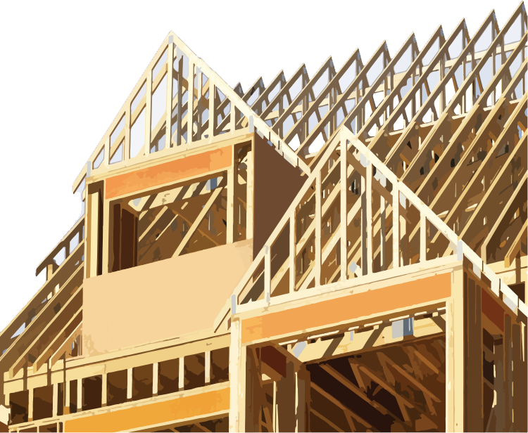

1. Project Overview

* Brief description of the residential project
* Objectives (e.g., new construction, renovation)

1. Owner Information

[COMPANY NAME]

[Point of Contact Name]

[Address Line 1]

[Address Line 2]

[Address Line 3]

[Phone: 000-000-0000]

[Fax: 000-000-0000]

[Email Address]

[Company Web Address]

1. Scope of Work

* Detailed tasks (e.g., foundation, framing, roofing)
* Specifications for materials and finishes

1. Project Requirements

* Budget range
* Timeline and deadlines
* Permits, codes, and zoning requirements

1. Proposal Instructions

* Submission format and deadline
* Required documents (e.g., qualifications, references, itemized cost breakdown)

6. Selection Criteria

* Basis for evaluation (e.g., experience, cost, quality)

1. Schedule

* Project milestones and completion date

1. Contract Terms

* Payment terms
* Insurance and warranties

1. Attachments

* Site plans, blueprints, or photos
* Bid forms or checklists

|  |
| --- |
| **DISCLAIMER**  Any articles, templates, or information provided by Smartsheet on the website are for reference only. While we strive to keep the information up to date and correct, we make no representations or warranties of any kind, express or implied, about the completeness, accuracy, reliability, suitability, or availability with respect to the website or the information, articles, templates, or related graphics contained on the website. Any reliance you place on such information is therefore strictly at your own risk. |