**](https://www.smartsheet.com/try-it?trp=12322&utm_source=template-word&utm_medium=content&utm_campaign=Renovation+Construction+RFP-word-12322&lpa=Renovation+Construction+RFP+word+12322)Renovation Construction  
RFP Template**



Company Name

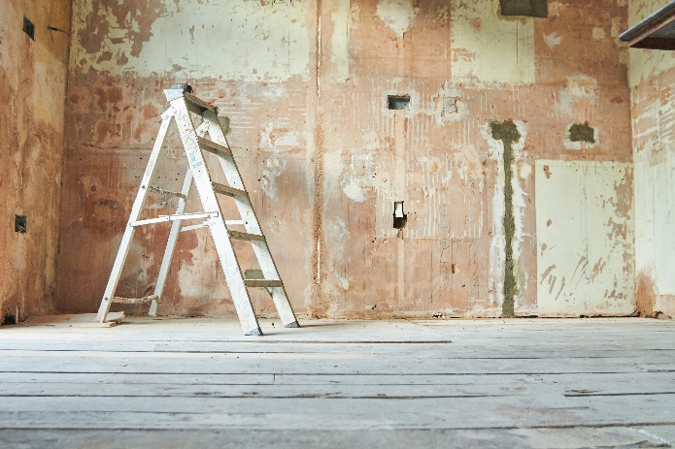

Your Logo

Project Overview

|  |  |
| --- | --- |
| Purpose | Explain the renovation project’s goals (e.g., updating facilities, restoring a historic building). |
| Location | Address |
| Scope Summary | Briefly outline the extent of the renovation. |

Background Information

|  |  |
| --- | --- |
| Site Details | Include relevant details about the building/site (e.g., age, existing conditions, structural limitations). |
| Client Information | Client name |
| *Point of Contact* |  |
| *Contact Details* |  |

Scope of Work

|  |  |
| --- | --- |
| Tasks | List specific renovation tasks (e.g., demolition, structural repairs, plumbing updates, finishing work). |
| Specifications | Include material requirements, design standards, or compliance needs. |

Permits

|  |  |  |
| --- | --- | --- |
| Permit Requirements | Responsibilities | Timeline |
| Building | Contractor | Due by MM/DD to avoid delays |
| Zoning | Contractor | Due by MM/DD to avoid delays |
| Electrical | Client |  |
|  |  |  |
|  |  |  |

Proposal Requirements

|  |  |
| --- | --- |
| Format |  |
| Supporting Documents |  |
| Submission Deadline |  |

Timeline

|  |  |  |
| --- | --- | --- |
| Start Date | Completion Date | Key Milestones |
|  |  |  |
|  |  |  |
|  |  |  |
|  |  |  |
|  |  |  |
|  |  |  |
|  |  |  |
|  |  |  |

Cost Breakdown

|  |  |  |  |  |  |  |
| --- | --- | --- | --- | --- | --- | --- |
| **Materials** | **Labor** | **Equipment** | **Miscellaneous/ Contingencies** | **Quantity** | **Rate** | **Total** |
| Description | Description | Description | Description | 0 | $0.00 | $0.00 |
| Description | Description | Description | Description | 0 | $0.00 | $0.00 |
| Description | Description | Description | Description | 0 | $0.00 | $0.00 |
|  |  |  |  |  |  |  |
|  |  |  |  |  |  |  |
|  |  |  |  |  |  |  |
|  |  |  |  |  |  |  |
|  |  |  |  |  |  |  |
|  |  |  |  |  |  |  |
|  |  |  |  |  |  |  |
|  |  |  |  |  |  |  |
|  |  |  |  |  |  |  |
| **Total** | | | | | | **$0.00** |

Sustainability

|  |  |
| --- | --- |
| Sustainable Practices | Specify sustainability goals (e.g., energy efficiency, use of eco-friendly materials). |
| Certifications | Mention required adherence to green building standards (e.g., LEED, Energy Star). |
| Waste Management | Detail requirements for recycling or reducing construction waste. |

Evaluation Criteria

|  |  |
| --- | --- |
| Selection Factors | Specify what will be evaluated (e.g., experience, pricing, proposed timeline). |
| Weighting | Indicate the importance of each criterion, if applicable. |

Terms and Conditions

|  |  |
| --- | --- |
| Payment Schedule | Define when payments will be made (e.g., milestone-based). |
| Insurance and Warranties | Require proof of liability coverage and workmanship guarantees. |
| Contractual Obligations | Include termination clauses and dispute resolution terms. |

Attachments

* **Relevant Documents:** Attach plans, photographs, or surveys.
* **Forms:** Provide templates for bid submissions or subcontractor lists.

Your Logo

|  |
| --- |
| **DISCLAIMER**  Any articles, templates, or information provided by Smartsheet on the website are for reference only. While we strive to keep the information up to date and correct, we make no representations or warranties of any kind, express or implied, about the completeness, accuracy, reliability, suitability, or availability with respect to the website or the information, articles, templates, or related graphics contained on the website. Any reliance you place on such information is therefore strictly at your own risk. |