**](https://www.smartsheet.com/try-it?trp=12322&utm_source=template-word&utm_medium=content&utm_campaign=Commercial+Construction+RFP-word-12322&lpa=Commercial+Construction+RFP+word+12322)Commercial Construction RFP Template**

**Your**

**Logo**

and company information

Commercial

Construction

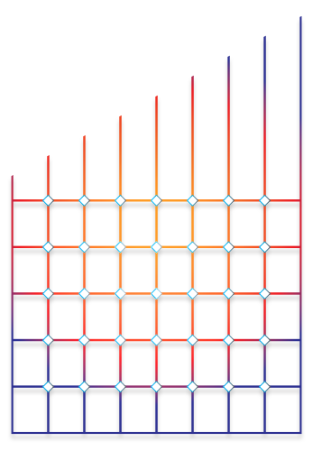Request for  
Proposal

Project Overview

|  |  |
| --- | --- |
| Project Title | Name |
| Project Type | (Office, retail, multi-use, industrial) |
| Project Purpose | Purpose of the project and key commercial objectives |

Owner / Client Information

Organization Name

Contact details for the RFP process

|  |  |  |
| --- | --- | --- |
| Name | Title | Contact Information |
| Name | Stakeholder | Phone, email |
| Name | Owner representative | Phone, email |
|  |  |  |
|  |  |  |
|  |  |  |
|  |  |  |
|  |  |  |

Scope of Work

|  |  |
| --- | --- |
| Phases | Detailed description of construction phases (e.g., site preparation, structural work, MEP systems, interior finishes) |
| Materials | Specific commercial-grade materials, energy efficiency standards, and LEED certification goals, if applicable |

Project Requirements

1. Adherence to commercial building codes, safety regulations, and zoning laws
2. Insurance coverage (e.g., liability, builder’s risk) and bonding requirements
3. Expectations for subcontractor management and procurement

Project Submission Requirements

1. Detailed qualifications, including previous commercial projects
2. Organizational structure, including project manager and key personnel
3. Cost breakdown, with allowances for specific items like HVAC systems or IT infrastructure

Evaluation Criteria

|  |  |
| --- | --- |
| Experience | Experience with similar commercial projects (e.g., size, type, complexity) |
| Financials | Financial stability and ability to meet tight deadlines |
| Value Engineering | Proposed value engineering options or innovative cost-saving solutions |
| Scoring | Description of how RFP scoring is weighed |
| Other |  |

Timeline and Schedule

Mention the target start and completion dates, including phased milestones (e.g., tenant-ready spaces, inspection deadlines). Include penalties for delays or non-compliance.

|  |  |  |
| --- | --- | --- |
| Phasing Descriptions / Milestones | Estimated  Start Date | Estimated Completion Date |
| Description |  |  |
|  |  |  |
|  |  |  |
|  |  |  |
|  |  |  |
|  |  |  |
|  |  |  |
|  |  |  |
|  |  |  |
|  |  |  |

Budget Guidelines

1. Total estimated budget and format for submitting bids
2. Allowances for contingency, specialized equipment, or tenant fit-outs

Terms and Conditions

* Payment terms tied to milestones (e.g., percentage of total project cost based on completion stage)
* Contractual obligations for warranties and liability periods
* Termination clauses and dispute resolution processes

Attachments

1. Detailed site plans, renderings, or CAD drawings
2. Zoning maps, environmental reports, or surveys
3. Pre-filled bid submission forms and other templates

|  |
| --- |
| **DISCLAIMER**  Any articles, templates, or information provided by Smartsheet on the website are for reference only. While we strive to keep the information up to date and correct, we make no representations or warranties of any kind, express or implied, about the completeness, accuracy, reliability, suitability, or availability with respect to the website or the information, articles, templates, or related graphics contained on the website. Any reliance you place on such information is therefore strictly at your own risk. |