**](https://www.smartsheet.com/try-it?trp=8754&utm_source=template-word&utm_medium=content&utm_campaign=Six+Sigma+Stakeholder+Analysis+Template-word-8754&lpa=Six+Sigma+Stakeholder+Analysis+Template+word+8754)Six Sigma Stakeholder Analysis**

**Template**

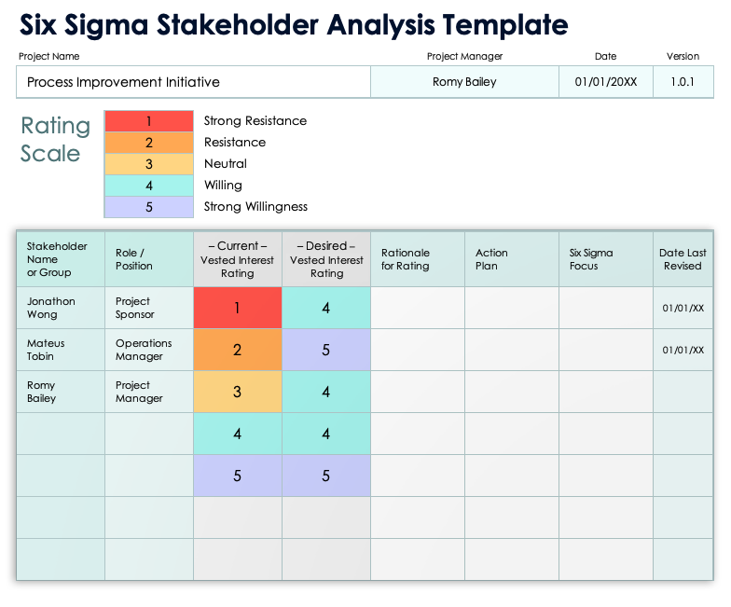

Blank template   
on page 2.

|  |  |  |  |
| --- | --- | --- | --- |
| Project Name | Project Manager | Date | Version |
|  |  |  |  |

|  |  |  |  |
| --- | --- | --- | --- |
| Rating Scale | 1 | Strong Resistance | Six Sigma Stakeholder Analysis |
| 2 | Resistance |
| 3 | Neutral |
| 4 | Willing |
| 5 | Strong Willingness |

|  |  |  |  |  |  |  |  |
| --- | --- | --- | --- | --- | --- | --- | --- |
| Stakeholder  Name  or Group | Role /  Position | – Current –  Vested Interest  Rating | – Desired – Vesting Interest  Rating | Rationale  for Rating | Action  Plan | Six Sigma  Focus | Date  Last Revised |
|  |  |  |  |  |  |  |  |
|  |  |  |  |  |  |  |  |
|  |  |  |  |  |  |  |  |
|  |  |  |  |  |  |  |  |
|  |  |  |  |  |  |  |  |

|  |
| --- |
| **DISCLAIMER**  Any articles, templates, or information provided by Smartsheet on the website are for reference only. While we strive to keep the information up to date and correct, we make no representations or warranties of any kind, express or implied, about the completeness, accuracy, reliability, suitability, or availability with respect to the website or the information, articles, templates, or related graphics contained on the website. Any reliance you place on such information is therefore strictly at your own risk. |