**](https://www.smartsheet.com/try-it?trp=12310&utm_source=template-word&utm_medium=content&utm_campaign=Sample+Fast+Food+Restaurant+Business+Plan+Template-word-12310&lpa=Sample+Fast+Food+Restaurant+Business+Plan+Template+word+12310)Fast Food Restaurant   
Business Plan Template Example**

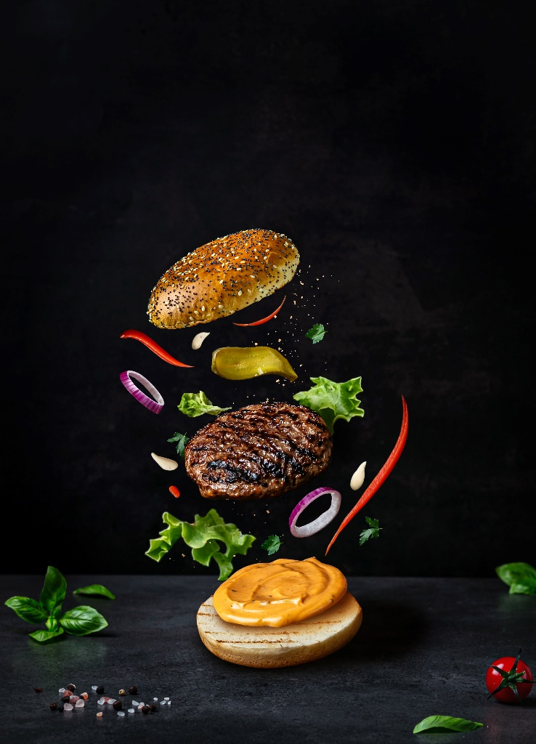

Business Plan

Rapid Bite Express

Date Prepared

07/19/20XX

Contact

Jason Desjardins

Owner/Operator

jdesjardins@rapidbiteexpress.com

(555) 456-0987

789 Quick Street

Metroville, USA

**rapidbiteexpress.com**

**@rapidbiteexpress**

Table of Contents

Executive Summary 3

Fast Food Restaurant Overview 3

Market Analysis 4

Target Market 4

Location Analysis 4

Competition Analysis 4

Menu and Product Line 5

Offerings and Pricing 5

Service Speed and Efficiency 5

Marketing Plan and Sales Strategy 6

Local Promotions and High-Volume Marketing 6

Operations Plan 7

Staffing for High Turnover Rates 7

Standardized Speed Processes 7

Supplier Relationships and Inventory Management 7

Health, Safety, and Drive-Through Compliance 7

Franchise Opportunities 8

Scalability and Expansion Potential 8

Franchise Development Overview 8

Management Structure 9

Financial Plan 10

Startup Costs and Funding Needs 10

Revenue Forecasts for High-Volume Operations 10

Implementation Timeline 11

Supporting Documents 12

# Burger and drink with solid fillExecutive Summary

|  |
| --- |
| Rapid Bite Express is a fast-food restaurant designed to meet the demand for quick, high-quality meals in Metroville’s bustling downtown area. With a focus on service speed and consistent quality, the restaurant offers freshly prepared burgers, wraps, and salads tailored to busy professionals and families. The business will open in November 20XX, with a projected monthly revenue of $75,000 and plans to expand into franchising within three years. |

# Person preparing saladFast Food Restaurant Overview

Rapid Bite Express combines classic fast-food and innovative menu items to meet evolving customer preferences. The restaurant will feature a drive-through and dine-in area, ensuring accessibility and convenience. Jason Desjardins, an experienced fast-food operations manager, will own and operate the business, supported by a team of trained staff. The business model emphasizes efficiency, affordability, and scalability.

# Market Analysis

## Target Market

|  |
| --- |
| The restaurant targets professionals, students, and families seeking affordable, fast, and fresh meals. Approximately 60% of the target audience resides within a three-mile radius, with an estimated annual spend of $500,000 on fast food. |

## Location Analysis

|  |
| --- |
| Rapid Bite Express will occupy a 2,000 sq. ft. corner lot with high visibility and traffic from nearby office complexes and schools. Over 15,000 vehicles pass the location daily, making it ideal for drive-through and walk-in customers. |

## Competition Analysis

|  |
| --- |
| Competitors include established fast-food chains and local eateries. Rapid Bite Express differentiates itself with faster service times, fresh ingredient sourcing, and exclusive menu items like the “turbo burger” and the “express wrap.” |

# Menu and Product Line

|  |  |
| --- | --- |
| Offerings and Pricing | The menu includes burgers, wraps, salads, and sides priced between $5 and $12. Signature items include the “Turbo Burger Meal” for value-conscious customers seeking quick and satisfying meals. |
| Service Speed and Efficiency | With an average service time of under three minutes per customer, Rapid Bite Express utilizes state-of-the-art kitchen equipment and streamlined workflows to ensure consistent speed during peak hours. |

# Marketing Plan and Sales Strategy

## Local Promotions and High-Volume Marketing

|  |
| --- |
| Rapid Bite Express will launch a dynamic marketing campaign, including a grand opening event, digital ads targeting commuters, and loyalty rewards. Weekly promotions like “Wrap Wednesdays” will drive repeat business. Partnerships with local schools and sports teams will create community engagement. |

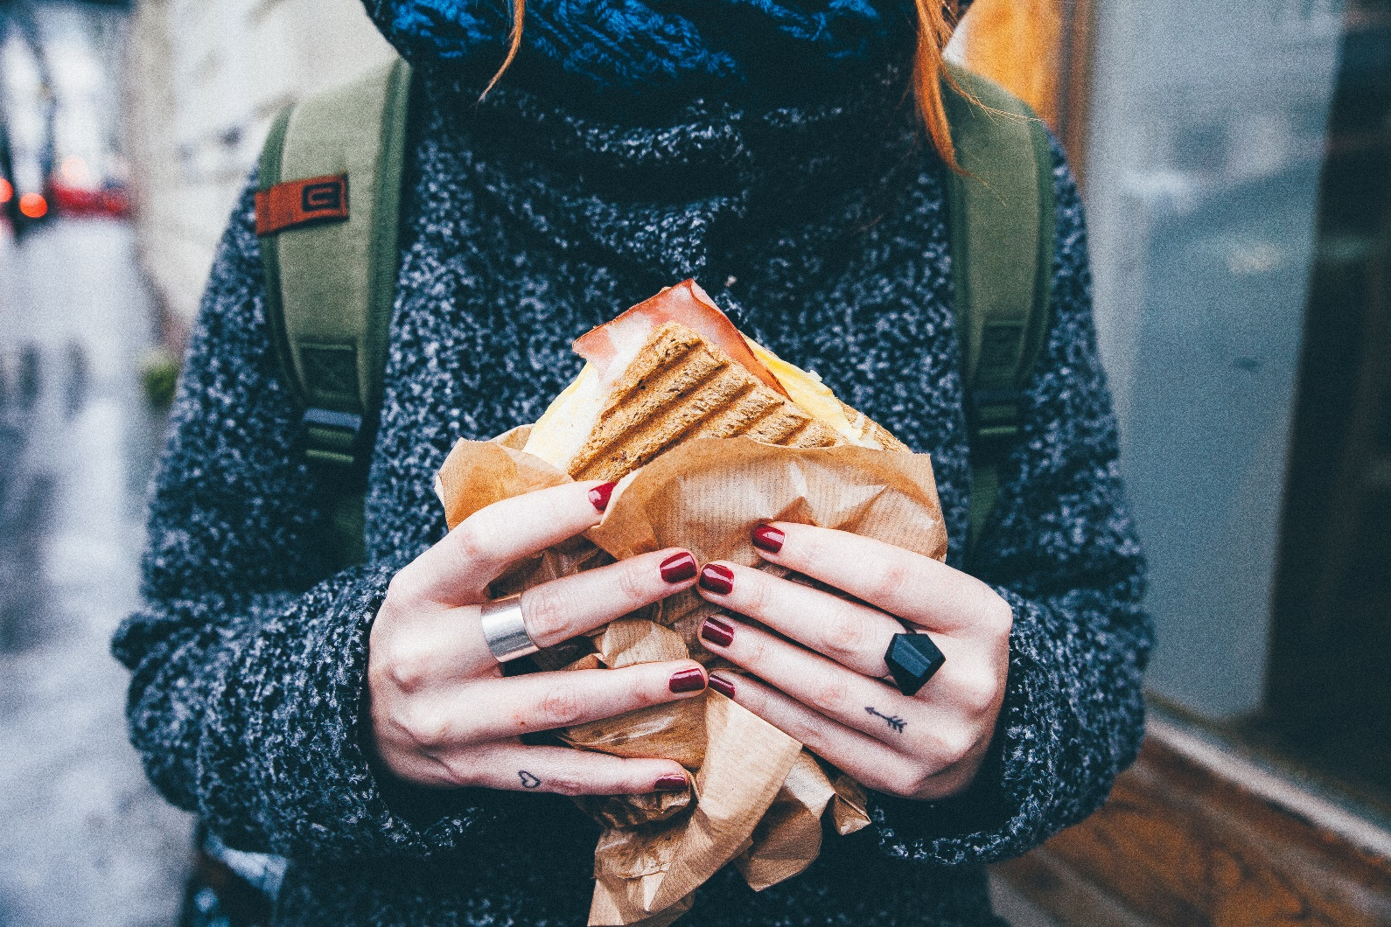

# Operations Plan

## Staffing for High Turnover Rates

|  |
| --- |
| The restaurant will employ 25 staff members, including cashiers, cooks, and supervisors. Recruitment will focus on high-energy individuals, with training programs designed to reduce turnover and maintain consistent service quality. |

## Standardized Speed Processes

|  |
| --- |
| Processes such as pre-portioning ingredients and automating fryers will optimize efficiency and reduce wait times. All staff will complete cross-training to enhance versatility. |

## Supplier Relationships and Inventory Management

|  |
| --- |
| Long-term agreements with regional distributors will ensure reliable ingredient supply and competitive pricing. Weekly inventory checks will minimize waste and maintain freshness. |

## Health, Safety, and Drive-Through Compliance

|  |
| --- |
| The restaurant will comply with local health codes and drive-through regulations, with ongoing staff training to maintain safety standards. |

# Franchise Opportunities

## Scalability and Expansion Potential

|  |
| --- |
| Rapid Bite Express promotes growth with a franchise-ready business model that includes standardized procedures and proven customer demand. The target expansion markets include suburban areas and college towns. |

## Franchise Development Overview

|  |
| --- |
| Potential franchisees will receive a comprehensive training program, marketing support, and detailed operational manuals to replicate the success of the flagship location. |

# Management Structure

|  |
| --- |
| Rapid Bite Express has a seasoned leadership team that delivers exceptional service and operational efficiency. The team combines years of expertise in fast-food management and customer engagement, ensuring the business meets its high-volume success and customer satisfaction goals. |

**Name, Role**

Experience and Qualifications

**Devon Gomez, Shift Manager**

8 years in food service, specializing in team leadership and customer satisfaction

**Jason Desjardins, Owner / Operator**

12 years managing multi-unit fast-food operations

# Financial Plan

## Startup Costs and Funding Needs

|  |
| --- |
| The startup budget of $300,000 will cover kitchen equipment, renovations, and initial marketing. Funding will come from personal investment and a $200,000 business loan. |

## Revenue Forecasts for High-Volume Operations

|  |
| --- |
| Revenue for the first year is projected at $900,000, with a profit margin of 20% achieved by streamlining operations and driving high customer volume. |

# Implementation Timeline

|  |  |  |
| --- | --- | --- |
| **Phase** | **Timeframe** | **Key Activities** |
| Phase 1 | Months 1–2 | Secure funding, finalize lease, begin construction |
| Phase 2 | Months 3–4 | Hire and train staff, install equipment, start pre-opening promotions |
| Phase 3 | Month 5 | Conduct soft opening, gather customer feedback |
| Phase 4 | Month 6 | Execute grand opening and launch of loyalty rewards program |
|  |  |  |

# Supporting Documents

|  |  |
| --- | --- |
| **Document** | **Purpose** |
| Lease Agreement | Securing location and occupancy terms |
| Health and Safety Certifications | Verifying food safety regulations compliance |
| Equipment Purchase Invoices | Providing proof of startup costs and equipment investments |
| Training Manuals | Ensuring consistency in operations and service quality |
| Marketing Collateral | Outlining strategies for brand awareness and customer engagement |

|  |
| --- |
| **DISCLAIMER**  Any articles, templates, or information provided by Smartsheet on the website are for reference only. While we strive to keep the information up to date and correct, we make no representations or warranties of any kind, express or implied, about the completeness, accuracy, reliability, suitability, or availability with respect to the website or the information, articles, templates, or related graphics contained on the website. Any reliance you place on such information is therefore strictly at your own risk. |