**](https://www.smartsheet.com/try-it?trp=12310&utm_source=template-word&utm_medium=content&utm_campaign=Sample%20Bakery%20Business%20Plan%20Template-word-12310&lpa=Sample%20Bakery%20Business%20Plan%20Template+word+12310)Bakery Business Plan   
Template Example**

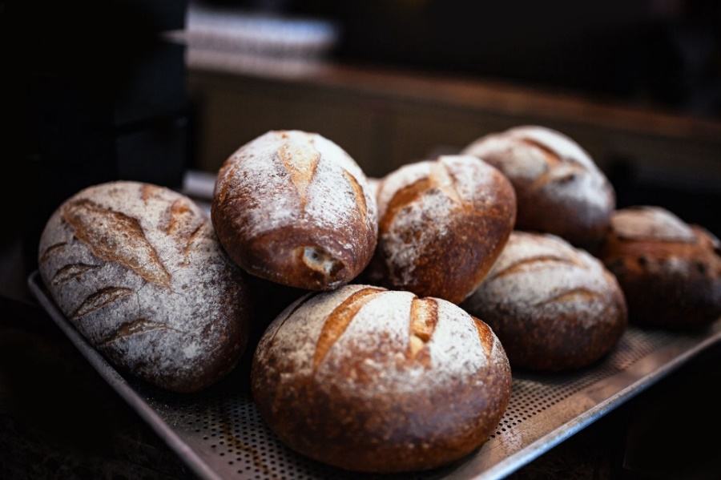

**Harvest Haven Bakery**

Business Plan

Date Prepared: 2/22/20XX

Contact: Leigh Gibbs, Owner/Head Baker, leighgibbs@example.com, (555)-789-6543

Address: 321 Confection Circle, Metro, USA

harvesthavenbakery.com | @harvesthaven

**TABLE OF CONTENTS**

**EXECUTIVE SUMMARY 3**

**BAKERY OVERVIEW 4**

**MARKET ANALYSIS 5**

**TARGET MARKET 5**

**LOCATION ANALYSIS 6**

**COMPETITION ANALYSIS 7**

**MENU AND PRODUCT LINE 8**

**BAKED GOODS** **OFFERINGS AND PRICING 8**

**SPECIALTY ITEMS** **AND CUSTOM ORDERS 8**

**MARKETING PLAN AND SALES STRATEGY 9**

**COMMUNITY OUTREACH AND WHOLESALE OPPORTUNITIES** **9**

**OPERATIONS PLAN 10**

**BAKERY** **STAFFING AND TRAINING 10**

**PRODUCTION AND INVENTORY MANAGEMENT 11**

**SUPPLIERS 12**

**EQUIPMENT AND MAINTENANCE 13**

**MANAGEMENT STRUCTURE 14**

**FINANCIAL PLAN 15**

**STARTUP COSTS AND EQUIPMENT INVESTMENTS 15**

**REVENUE PROJECTIONS FOR RETAIL AND WHOLESALE OPERATIONS 15**

**IMPLEMENTATION TIMELINE 16**

**SUPPORTING DOCUMENTS 16**

# **Executive Summary**

|  |
| --- |
| Harvest Haven Bakery is a boutique bakery specializing in artisan breads, pastries, and custom cakes. Located in the heart of Metro, the bakery combines traditional baking techniques with modern flavors to serve a growing demand for high-quality, handcrafted baked goods. The bakery aims to attract over 250 customers daily and generate $250,000 in revenue during its first year. Our vision is to become the city’s premier bakery, celebrated for its fresh ingredients, creative offerings, and exceptional customer service. |

# **Bakery Overview**

|  |
| --- |
| Harvest Haven Bakery offers a diverse selection of baked goods made fresh daily. Every item uses locally sourced ingredients, from flaky croissants to elegant wedding cakes. The bakery features a cozy, welcoming atmosphere with seating for 20 customers, encouraging guests to enjoy their treats on-site. Owned and operated by Leigh Gibbs, a pastry chef with 15 years of experience, Harvest Haven Bakery is committed to delivering quality and creativity in every bite. |

# **Market Analysis**

## **Target Market**

|  |
| --- |
| Harvest Haven Bakery targets a diverse customer base, including busy professionals, families, and special event planners. The core demographic consists of individuals aged 25–50 who value artisanal quality and are willing to spend more on premium baked goods. Market research indicates a 20% year-over-year increase in demand for boutique bakeries within town. |

## **Location Analysis**

|  |
| --- |
| The bakery will be located in the vibrant downtown district, known for its shopping and dining scene. The area sees consistent foot traffic from nearby offices, residential communities, and weekend tourists, making it ideal for capturing weekday and weekend sales. |

## **Competition Analysis**

|  |
| --- |
| Harvest Haven Bakery competes with local grocery store bakeries and large chain cafés. However, the bakery differentiates itself by focusing on customization, organic ingredients, and unique flavor profiles. No other bakery in the area offers the same combination of personalized service and high-quality products. |

# **MENU AND PRODUCT LINE**

## **Baked Goods Offerings and Pricing**

|  |
| --- |
| The bakery’s core menu includes artisan bread, seasonal pastries, and cupcakes which range from $2.50 to $6.00 per item. Popular offerings, such as the cinnamon swirl loaf and the triple chocolate croissant, will cater to both regular customers and first-time visitors. |

## **Specialty Items and Custom Orders**

|  |
| --- |
| Specialty offerings include themed cakes, dessert platters, and gift baskets. Custom cake designs start at $75 and cater to weddings, birthdays, and corporate events. Custom orders require two business days’ notice to ensure quality and attention to detail. |

# **Marketing Plan And Sales Strategy**

## **Community Outreach and Wholesale Opportunities**

|  |
| --- |
| Harvest Haven Bakery will implement a multi-faceted marketing strategy, leveraging social media platforms to highlight menu items, seasonal specials, and customer testimonials. Collaborations with local cafés and event planners will expand reach, while in-store promotions such as “Tasting Tuesdays” will encourage repeat visits. Additionally, the bakery will offer wholesale opportunities to local restaurants and coffee shops to increase revenue streams. |

# **Operations Plan**

## **Bakery Staffing and Training**

|  |
| --- |
| The bakery will employ 10 staff members, including bakers, decorators, and counter associates. Employees will complete a two-week onboarding program focused on quality control, customer service, and food safety standards. |

## **Production and Inventory Management**

|  |
| --- |
| Baking schedules will optimize freshness, with breads and pastries prepared daily before opening. Weekly inventory checks will minimize waste and ensure consistent supply levels. |

## **Suppliers**

|  |
| --- |
| Harvest Haven Bakery will partner with local farms and distributors to source organic flour, dairy products, and seasonal fruits. Contracts with regional suppliers will ensure cost stability and high-quality ingredients. |

## **Equipment and Maintenance**

|  |
| --- |
| The bakery’s equipment includes commercial ovens, stand mixers, and refrigerated display cases. Monthly maintenance checks will ensure all machinery operates efficiently and meets safety standards. |

# **Management Structure**

|  |
| --- |
| Harvest Haven Bakery features a dedicated team focused on culinary excellence and operational efficiency.  **Leigh Gibbs, Owner / Head Baker**  15 years as a pastry chef, specializing in artisan and custom baking  **Makara McLean, Operations Manager**  10 years in food service management, with expertise in inventory control and staff training |

# **Financial Plan**

## **Startup Costs and Equipment Investments**

|  |
| --- |
| Startup costs for Harvest Haven Bakery total $120,000 and cover leasehold improvements, equipment purchases, and marketing. Funding will include $40,000 in personal savings and an $80,000 business loan. |

## **Revenue Projections for Retail and Wholesale Operations**

|  |
| --- |
| The bakery expects to generate $250,000 in revenue during its first year, with retail sales accounting for 80% and wholesale orders contributing 20%. Revenue is expected to grow by 15% annually as customer loyalty and wholesale partnerships expand. |

# **Implementation Timeline**

|  |  |  |
| --- | --- | --- |
| **Phase** | **Timeframe** | **Key Activities** |
| Phase 1 | Months 1–2 | Finalize lease, purchase equipment, hire staff |
| Phase 2 | Month 3 | Conduct staff training, launch pre-opening promotions |
| Phase 3 | Month 4 | Open doors to customers, gather initial feedback |
| Phase 4 | Month 5 | Expand marketing efforts and wholesale partnerships |
|  |  |  |

# **Supporting Documents**

|  |  |
| --- | --- |
| **Document** | **Purpose** |
| Lease Agreement | Confirming terms for the downtown bakery location |
| Equipment Purchase Invoices | Detailing startup costs for baking tools and appliances |
| Vendor Contracts | Ensuring consistent supply of premium ingredients |
| Staff Training Manuals | Standardizing operations and customer service practices |
| Marketing Campaign Materials | Outlining promotional strategies for the grand opening |

|  |
| --- |
| **DISCLAIMER**  Any articles, templates, or information provided by Smartsheet on the website are for reference only. While we strive to keep the information up to date and correct, we make no representations or warranties of any kind, express or implied, about the completeness, accuracy, reliability, suitability, or availability with respect to the website or the information, articles, templates, or related graphics contained on the website. Any reliance you place on such information is therefore strictly at your own risk. |