AGILE PLANNING POKER DECK TEMPLATE
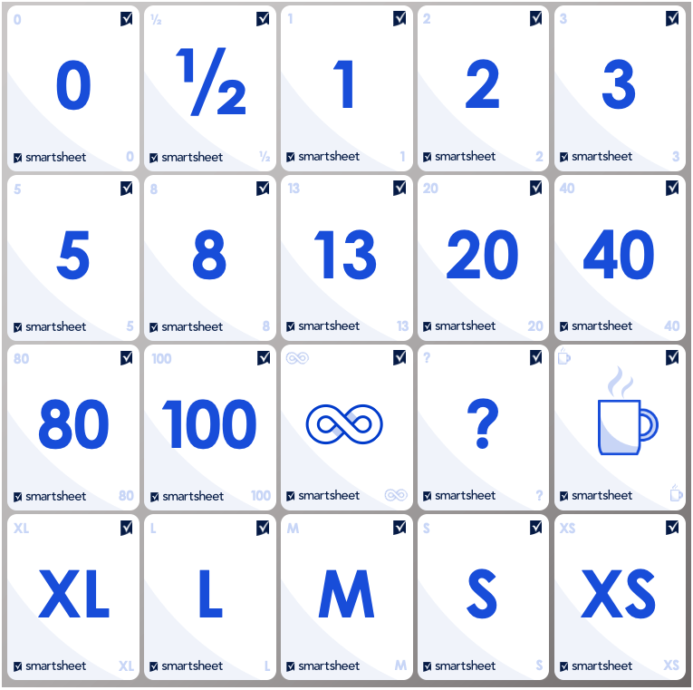
Planning Poker is a collaborative technique that Agile teams use to estimate and assign relative values to tasks. Print out this card deck template and cut out a set of cards for each member of your Agile team.

Follow the steps below to use these Agile Planning Poker cards:

- Setup
Gather the team and make sure each team member has their own deck of Planning Poker cards.
- Introduction
The product owner explains a user story or feature for which each team member estimates a value.
- Card Selection
Each estimator privately selects a card that represents their estimate. Each number corresponds to the number of story points or days or the relative effort that the team should expend for each user story or feature.
- Reveal and Discussion
Everyone reveals their chosen cards. Estimators discuss differing estimates and reasons behind their choices. High and low estimators explain their viewpoints. If there's a unanimous choice, that becomes the estimate.
If not, the team discusses the discrepancy until it reaches a consensus. Use the coffee cup
card to signal a break.

DISCLAIMER

Any articles, templates, or information provided by Smartsheet on the website are for reference only. While we strive to keep the information up to date and correct, we make no representations or warranties of any kind, express or implied, about the completeness, accuracy, reliability, suitability, or availability with respect to the website or the information, articles, templates, or related graphics contained on the website. Any reliance you place on such information is therefore strictly at your own risk.

