**](https://www.smartsheet.com/try-it?trp=12401&utm_source=template-word&utm_medium=content&utm_campaign=SEO)Construction Service SOP Template**

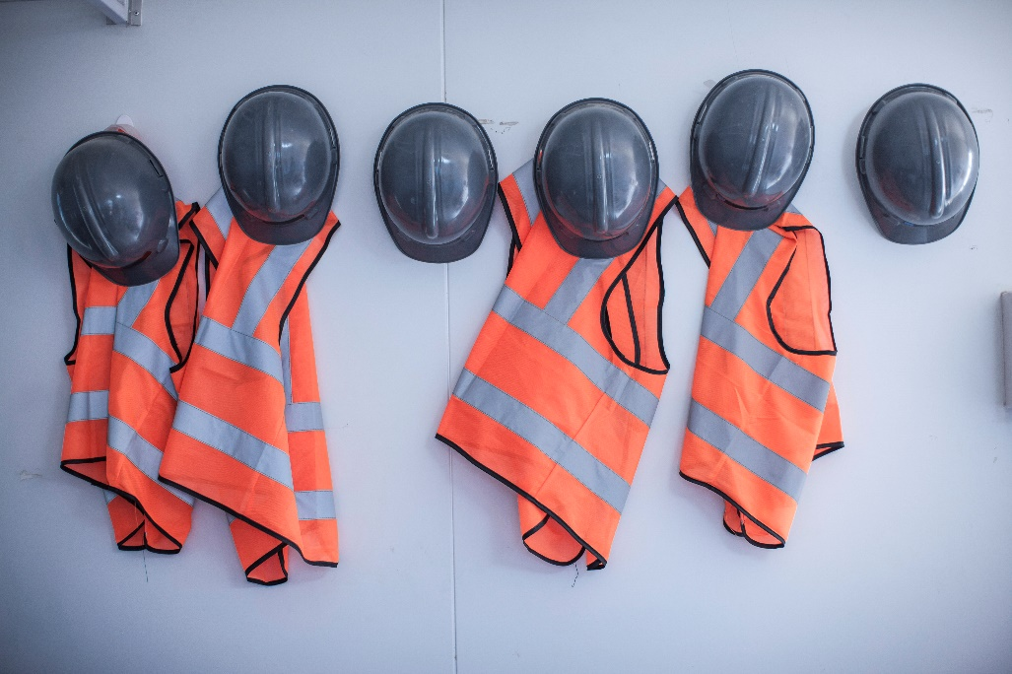**Construction**Standard Operating

Procedures

COMPANY NAME

Street Address

City, State, and Zip

webaddress.com

Version 0.0.0

Date: MM/DD/YY

Department Responsible: Name

| Version History | | | |
| --- | --- | --- | --- |
| Version No. |  | Current Version Date |  |
| **Effective Date** |  | **Expiration Date** |  |
| **Responsible Person** |  | **Signature** |  |
| **Writer** |  | **Approval** |  |

**Purpose**

*Explain why this SOP exists. For example: This SOP provides standardized procedures to ensure safe, efficient, and compliant execution of [specific construction activity, e.g., concrete pouring or site excavation].*

|  |
| --- |
| Applicable Sites/Projects:  Construction Phase(s):  Limitations/Exclusions: |

**Scope**

*Define where this SOP applies.*

|  |
| --- |
|  |

**References and Standards**

*List any codes, standards, or manuals relevant to this SOP (e.g., OSHA standards, local building codes, company safety manual).*

|  |
| --- |
|  |

**Roles and Responsibilities**

|  |  |
| --- | --- |
| **Project Manager** | Overall responsibility for compliance and approval. |
| **Site Supervisor** | Oversee on-site execution and enforce safety. |
| **Crew Member** | Carry out tasks as per procedure. |
| **Safety Officer** | Conducts inspections and ensures PPE compliance. |
| **Quality Control** |  |
| **Scheduler** |  |
| **Project Engineer** |  |
| **Preconstruction** |  |
| **Design Manager** |  |
| **Other** |  |
|  |  |

**Required Materials, Equipment, and PPE**

|  |  |
| --- | --- |
| **Tools** | |
|  | |
| **Materials** | |
|  | |
| **PPE** | |
| **x** | Hard Hat |
|  | Safety Boots |
|  | High-visibility vest |
|  | Gloves |
|  | Safety Glasses |
|  | Other |
| **Other** | |
|  | |

**Procedure**

*Outline clear, numbered steps. Example structure:*

|  |  |
| --- | --- |
| 1. **Conduct pre-task safety briefing** | Description |
| 1. **Inspect work area for hazards** | Description |
| 1. **Gather and inspect required equipment** | Description |
| 1. **Perform activity** | Description |
| 1. **Conduct quality checks at each milestone** | Description |
| 1. **Record inspection results in site log** | Description |
| 1. **Secure site and clean work area after completion** | Description |

**Safety and Risk Controls**

|  |
| --- |
| **Job-Specific Hazards** |
|  |
| **Control Measures** |
|  |
| **Emergency Procedures** |
|  |
| **Other** |
|  |

**Inspection and Quality Checks**

|  |
| --- |
| **Inspection Criteria** |
|  |
| **Required Signoffs** |
|  |
| **Documentation to File** |
|  |
| **Other** |
|  |

**Records and Documentation**

|  |
| --- |
| All forms, permits, and logs associated with this SOP must be stored in:  Project file / shared drive location:  Retention period: |

**Approval / Sign-Off**

|  |  |  |  |
| --- | --- | --- | --- |
| **Role** | **Name** | **Signature** | **Date** |
|  |  |  |  |
|  |  |  |  |
|  |  |  |  |
|  |  |  |  |

|  |
| --- |
| **DISCLAIMER**  Any articles, templates, or information provided by Smartsheet on the website are for reference only. While we strive to keep the information up to date and correct, we make no representations or warranties of any kind, express or implied, about the completeness, accuracy, reliability, suitability, or availability with respect to the website or the information, articles, templates, or related graphics contained on the website. Any reliance you place on such information is therefore strictly at your own risk. |