
Business Model Canvas /
Lean Canvas Template Example

Template begins on page 2.

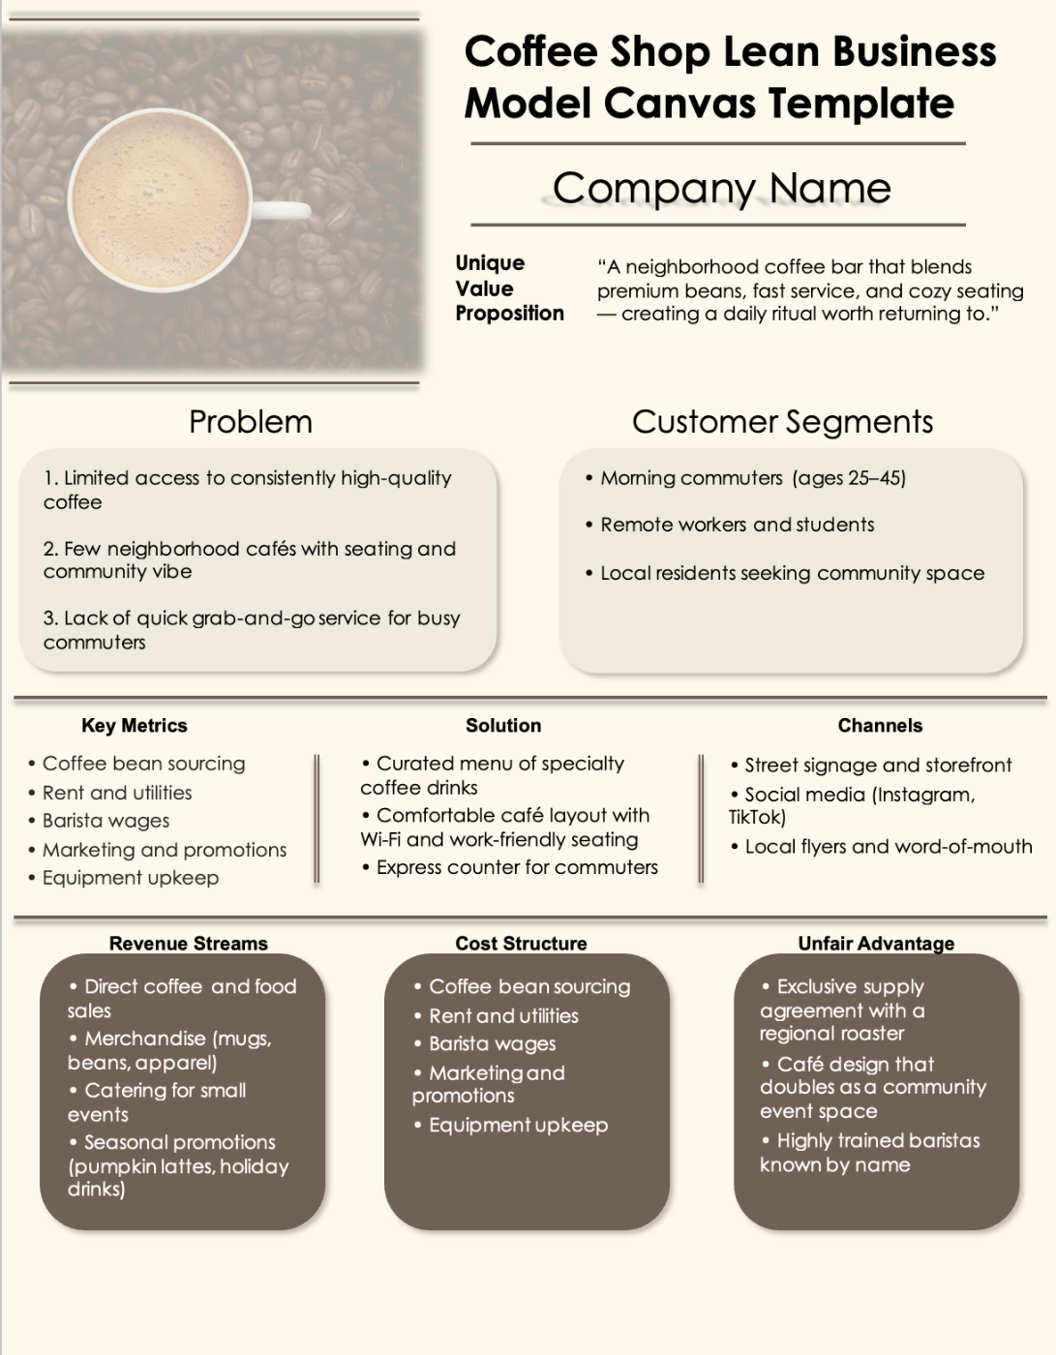

• Morning commuters (ages 25–45)
• Remote workers and students
• Local residents seeking community space
Customer Segments
Problem
1. Limited access to consistently high-quality coffee
2. Few neighborhood cafés with seating and community vibe.
3. Busy commuters lack quick grab-and-go service.
Company Name


Coffee Shop Lean Business Model Canvas Template

Company Name

Unique Value Proposition
“A neighborhood coffee bar that blends premium beans, fast service, and cozy seating — creating a daily ritual worth returning to.”

Customer Segments
Problem
1. Limited access to consistently high-quality coffee
2. Few neighborhood cafés with seating and community vibe
3. Lack of quick grab-and-go service for busy commuters
• Morning commuters (ages 25–45)
• Remote workers and students
• Local residents seeking community space

Key Metrics
Channels
Solution
• Street signage and storefront
• Social media (Instagram, TikTok)
• Local flyers and word-of-mouth
• Coffee bean sourcing
• Rent and utilities
• Barista wages
• Marketing and promotions
• Equipment upkeep

• Curated menu of specialty coffee drinks
• Comfortable café layout with Wi-Fi and work-friendly seating
• Express counter for commuters

Unfair Advantage
Cost Structure
Revenue Streams
• Direct coffee and food sales
• Merchandise (mugs, beans, apparel)
• Catering for small events
• Seasonal promotions (pumpkin lattes, holiday drinks)
• Coffee bean sourcing
• Rent and utilities
• Barista wages
• Marketing and promotions
• Equipment upkeep
• Exclusive supply agreement with a regional roaster
• Café design that doubles as a community event space
• Highly trained baristas known by name

Lean Business Model Canvas Template

Company Name

Unique Value Proposition

Customer Segments
Problem
1.
2.
3.
•
•
•

Key Metrics
Channels
Solution
•
•
•
•
•
•

•
•
•

Unfair Advantage
Cost Structure
Revenue Streams
•
•
•

•
•
•

•
•
•

DISCLAIMER

Any articles, templates, or information provided by Smartsheet on the website are for reference only. While we strive to keep the information up to date and correct, we make no representations or warranties of any kind, express or implied, about the completeness, accuracy, reliability, suitability, or availability with respect to the website or the information, articles, templates, or related graphics contained on the website. Any reliance you place on such information is therefore strictly at your own risk.

