
Bakery Business Plan Template

Template begins on page 2.

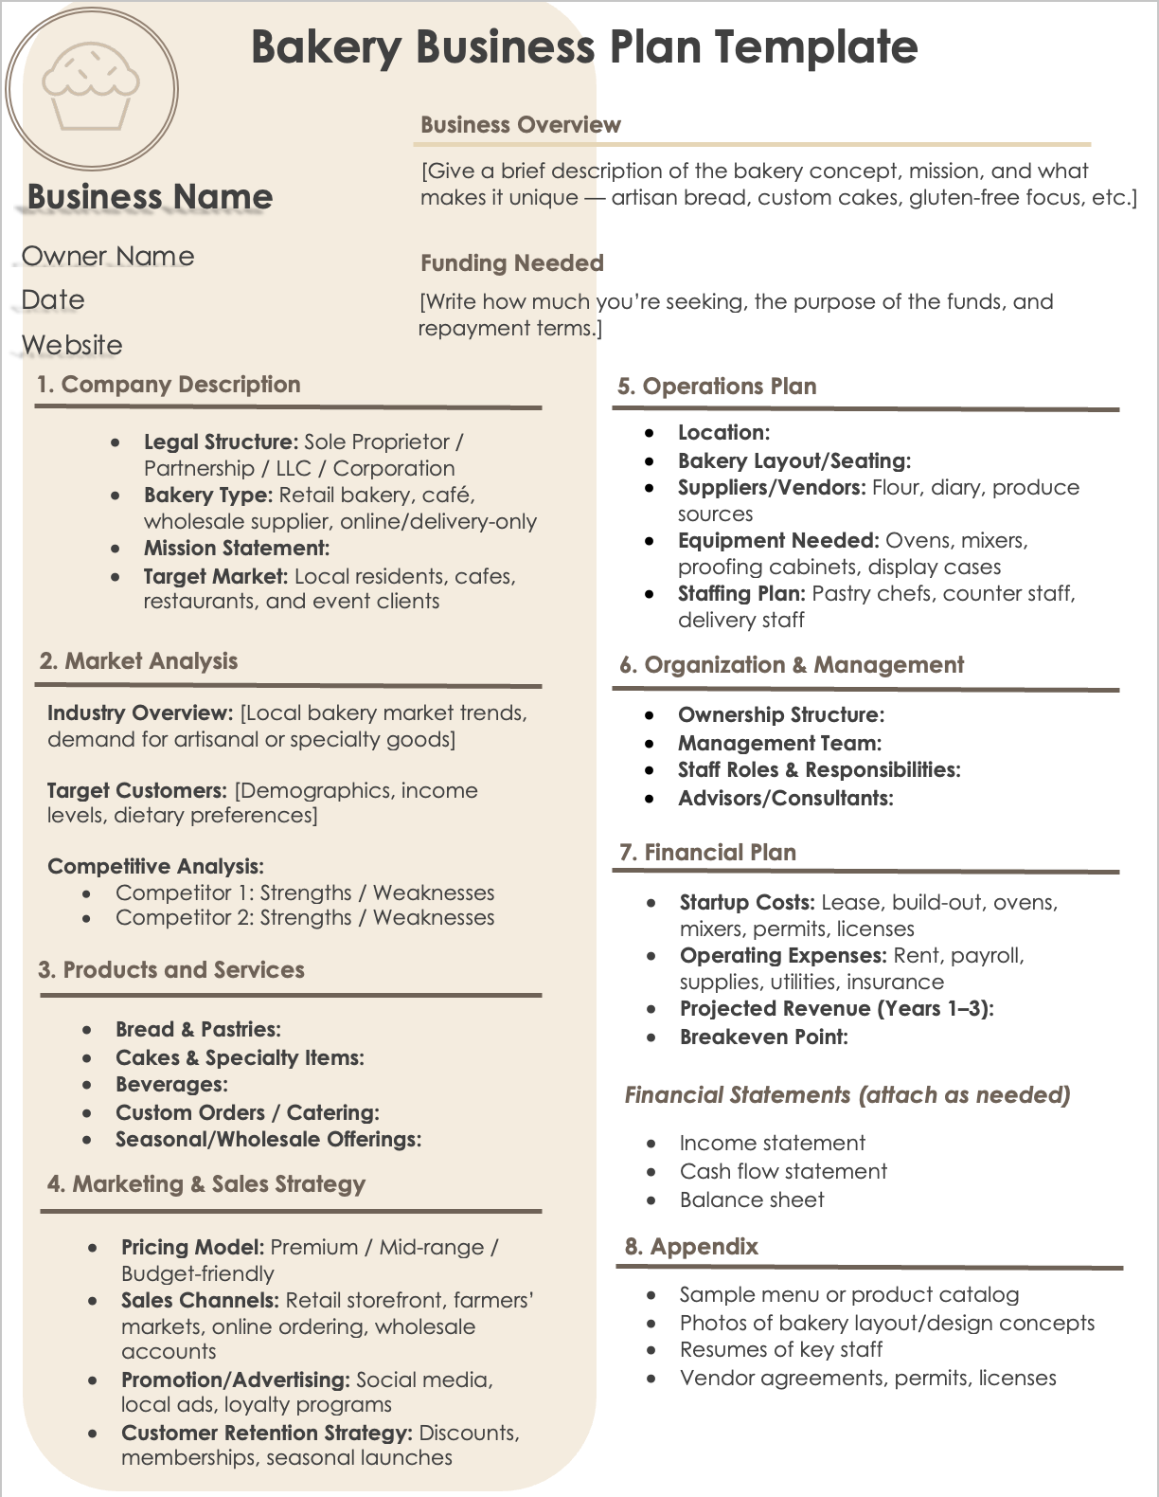


Bakery Business Plan Template
[Give a brief description of the bakery concept, mission, and what makes it unique — artisan bread, custom cakes, gluten-free focus, etc.]
Business Overview
Business Name

Owner Name
Funding Needed
Date
[Write how much you’re seeking, the purpose of the funds, and repayment terms.]
Website

1. Company Description
5. Operations Plan
- Legal Structure: Sole Proprietor / Partnership / LLC / Corporation
- Bakery Type: Retail bakery, café, wholesale supplier, online/delivery-only
- Mission Statement:
- Target Market: Local residents, cafes, restaurants, and event clients
- Location:
- Bakery Layout/Seating:
- Suppliers/Vendors: Flour, diary, produce sources
- Equipment Needed: Ovens, mixers, proofing cabinets, display cases
- Staffing Plan: Pastry chefs, counter staff, delivery staff

2. Market Analysis
6. Organization & Management
- Ownership Structure:
- Management Team:
- Staff Roles & Responsibilities:
- Advisors/Consultants:
Industry Overview: [Local bakery market trends, demand for artisanal or specialty goods]
Target Customers: [Demographics, income levels, dietary preferences]
Competitive Analysis:
- Competitor 1: Strengths / Weaknesses
- Competitor 2: Strengths / Weaknesses

7. Financial Plan
- Sample menu or product catalog
- Photos of bakery layout/design concepts
- Resumes of key staff
- Vendor agreements, permits, licenses
8. Appendix
- Income statement
- Cash flow statement
- Balance sheet
Financial Statements (attach as needed)
- Startup Costs: Lease, build-out, ovens, mixers, permits, licenses
- Operating Expenses: Rent, payroll, supplies, utilities, insurance
- Projected Revenue (Years 1–3):
- Breakeven Point:
- Pricing Model: Premium / Mid-range / Budget-friendly
- Sales Channels: Retail storefront, farmers’ markets, online ordering, wholesale accounts
- Promotion/Advertising: Social media, local ads, loyalty programs
- Customer Retention Strategy: Discounts, memberships, seasonal launches
4. Marketing & Sales Strategy
- Bread & Pastries:
- Cakes & Specialty Items:
- Beverages:
- Custom Orders / Catering:
- Seasonal/Wholesale Offerings:
3. Products and Services
Bakery Business Plan Template
[Give a brief description of the bakery concept, mission, and what makes it unique — artisan bread, custom cakes, gluten-free focus, etc.]
Business Overview
Business Name

Owner Name
Funding Needed
Date
[Write how much you’re seeking, the purpose of the funds, and repayment terms.]
Website

1. Company Description
5. Operations Plan
- Legal Structure:
- Bakery Type:
- Mission Statement:
- Target Market:
- Location:
- Bakery Layout/Seating:
- Suppliers/Vendors:
- Equipment Needed:
- Staffing Plan:

2. Market Analysis
6. Organization & Management
- Ownership Structure:
- Management Team:
- Staff Roles & Responsibilities:
- Advisors/Consultants:
Industry Overview:
Target Customers:
Competitive Analysis:
- Competitor 1: Strengths / Weaknesses
- Competitor 2: Strengths / Weaknesses

7. Financial Plan
- Sample menu or product catalog
- Photos of bakery layout/design concepts
- Resumes of key staff
- Vendor agreements, permits, licenses
8. Appendix
- Income statement
- Cash flow statement
- Balance sheet
Financial Statements (attach as needed)
- Startup Costs:
- Operating Expenses:
- Projected Revenue (Years 1–3):
- Breakeven Point:
- Pricing Model:
- Sales Channels:
- Promotion/Advertising:
- Customer Retention Strategy:
4. Marketing & Sales Strategy
- Bread & Pastries:
- Cakes & Specialty Items:
- Beverages:
- Custom Orders / Catering:
- Seasonal/Wholesale Offerings:
3. Products and Services

DISCLAIMER

Any articles, templates, or information provided by Smartsheet on the website are for reference only. While we strive to keep the information up to date and correct, we make no representations or warranties of any kind, express or implied, about the completeness, accuracy, reliability, suitability, or availability with respect to the website or the information, articles, templates, or related graphics contained on the website. Any reliance you place on such information is therefore strictly at your own risk.

