
Risk Control Matrix Template

Risk ID | Risk Title | Description | Category | Risk Likelihood (1–4) | Severity  (1-4) | Risk Score | Recommended Action | Owner | Status | Notes
 |  |  |  | 1 | 1 | 1 | Avoid
 |  |  |  | 4 | 4 | 16 | Accept
 |  |  |  | 3 | 3 | 9 | Avoid
 |  |  |  | 2 | 2 | 4 | Mitigate

Matrix Key
Likelihood 1–4 | 1 = Rare | 2 = Unlikely | 3 = Likely | 4 = Almost Certain
Severity 1–4 | 1 = Minimal | 2 = Minor | 3 = Major | 4 = Critical
Accept | Risk is acceptable; no action needed
Allow | Monitor and review periodically
Mitigate | Reduce likelihood or impact
Avoid | Eliminate the risk entirely

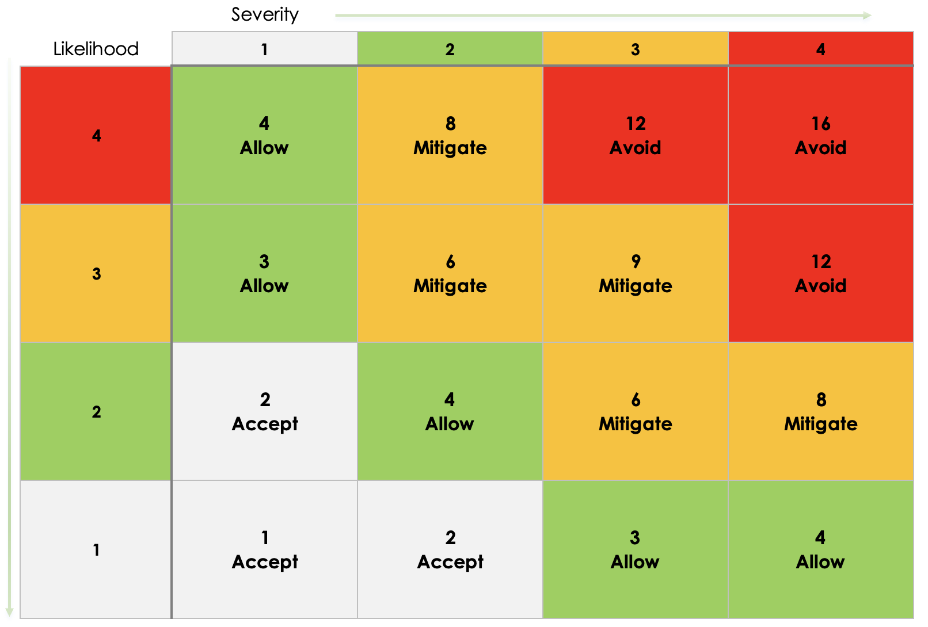

DISCLAIMER

Any articles, templates, or information provided by Smartsheet on the website are for reference only. While we strive to keep the information up to date and correct, we make no representations or warranties of any kind, express or implied, about the completeness, accuracy, reliability, suitability, or availability with respect to the website or the information, articles, templates, or related graphics contained on the website. Any reliance you place on such information is therefore strictly at your own risk.

