DATE: | Thursday, March 3, 2016
TIME: | 10:30 AM
LOCATION: | Conference Room B
MEETING MINUTES

Call to Order
- Team Name / Organization
- Meeting to Discuss
Click here to explore additional templates and resources for free in 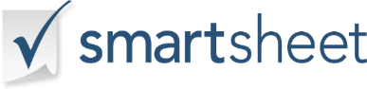
  - 2017 Business Practices
- Attendee Names
  - Sarah Hudson, Steve Hart
- Attendees Not Present
  - Anna James, Ken Smith

Approval of Previous Minutes
Remarks
Reports
Remarks
Unfinished Business
Remarks
Motions
Remarks
New Business
Remarks
Announcements
Remarks
Other Business
Remarks
Adjournment
Remarks
SECRETARY APPROVAL:
(Signature & Date)

